
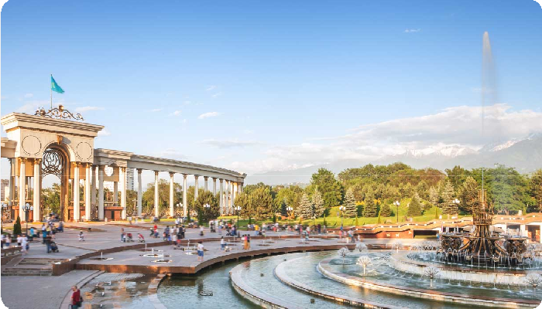








Package Details

Package Summary

Package: Wonders of Almaty

No of Nights: 4 Nights or 5 Days

Timeline: Almaty (4N )

Inclusions:

Flights Hotel Meals Transfer Sightseeing

Visa Tour Manager Group Tour




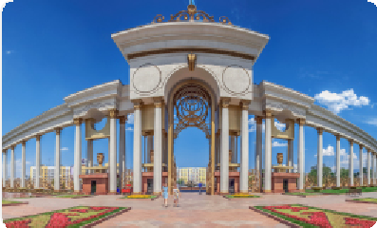

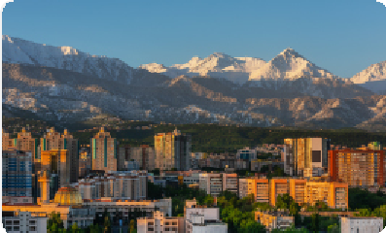

Daywise Itinerary

Day 1

Welcome to Almaty, Kazakhstan - Arrival - Check in - Almarasan
Welcome to Kazakhstan. On arrival in Almaty our local representative outside the baggage hall area at the airport. Proceed to the hotel. Check into your hotel (Standard Check in time after 1500Hrs). Later proceed for Alma-Arasan is a picturesque mountain gorge and natural hot spring located in the Trans-Ili Alatau mountains, just southwest of Almaty, Kazakhstan

Overnight in Almaty. (L, D)

Day 2

Almaty Orientation Tour – Visit Panfilov Park & Zenkov Cathedral - Visit Kok Tobe
After buffet breakfast proceed for city tour to know more about history and development of the southern capital of Kazakhstan and see it's main attractions; First, visit the Zenkov Cathedral at Panfilov Park. Built in 1907, this century-old Russian Cathedral is the second-tallest wooden building in the world which is made without using any nails! Next, explore the historic Panfilov Park, named after the 28 soldiers of an Almaty infantry and marvel at the spectacular Eternal Flame monument. The Central State Museum of the Republic of Kazakhstan, the Presidential Residence, the Republic Square and the Independence Monument, the Theater of Opera and Ballet named after Abai, Astana Square, Abai Square and the Palace of the Republic. After lunch visit Kok-Tobe, the highest TV tower in the world. A special viewing platform located on the mountain will allow you to admire the magnificent panorama of the city, as well as stroll along the winding paths of Kok-Tobe Park.

Overnight in Almaty. (B, L, D)

Day 3

Day Excursion to Shyumbulak Ski Resort
Today after buffet breakfast, proceed on an exciting drive to the Shymbulak Ski Resort. Located in the majestic Zailiyskiy Alatau

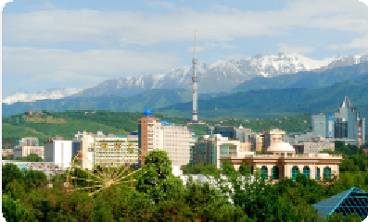

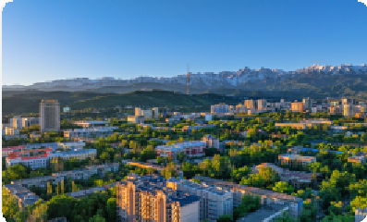

mountain ranges, the resort was once a training base for Soviet skiers. Embark on a fun cable car ride and admire the panoramic views of the mountains as you make your way up to Level 3 of the ski resort. Dotted with beautiful cafes, restaurants, plush hotels, perfect slopes and a playground, the resort is sure to provide a magical experience like no other.Your tour ends with a drop-off to your hotel in Almaty.

Overnight in Almaty. (B, L, D)

Day 4

Day Excursion to Charyn Canyon and Kolsay Lake
This morning after buffet breakfast, proceed to visit the Charyn Canyon, visit the Valley of Castles at Charyn Canyon - featuring towering rock pillars that resemble ancient fortresses, sculpted by wind and water erosion over millennia. Beyond the Valley of Castles, Charyn Canyon encompasses other impressive sections like the Temirlik Canyon, Yellow Canyon (or Moon Canyon), and Black Canyon, each offering unique geological features. Later we proceed to visit the Kolsai Lake - "Pearls of Tien Shan Mountains", a series of three stunning lakes nestled amidst the picturesque Tian Shan mountains. Drive back to Almaty city.

Overnight in Almaty. (B, PL, D)

Day 5

Fly back home
Today after breakfast at your hotel, we will drive to Almaty airport as this fantastic tour comes to an end. Return home with wonderful memories of your tour. (B)
Note : The above itinerary is tentative and subjected to change without prior notice.


Flights
- Round trip flights included
- Roundtrip flights are included as per user's selection post price calculation.




Visa Details
- Indian passport holders are eligible for visa-free entry for up to 14 days.
- Documents required: Passport with 6 months validity, Flight & Hotel Booking, Proof of Funds, Travel Insurance
Transfers
- Transfers and surface transport as mentioned in the itinerary
Sightseeing
- Almaty City Tour
- Visit Panfilov Park
- Visit Zenkov Cathedral
- Visit Kok Tobe
- Excursion Shymbulak Mountain & Ski Resort
- Excursion Charyn Canyon and Kolsay Lake
- Visit Almarasan
Accommodation
- 4 nights accomodation at Hotel Best Western / Ramada by whyndham or similar


Meals
- Daily breakfast. (Except Day 1)
- 03 Indian vegetarian/non-vegetarian lunches
- 01 Pack Lunch
- 04 Indian vegetarian/non-vegetarian dinners


Inclusions

What your tour price includes?

- Return economy class airfare as per the itinerary.
- Accommodations at the hotels specified or similar.
- Airport taxes (Any further increase in the same must be borne by the guest).
- Service of Tour Manager or a professional local representative. (subjected to minimum 15 customers)
- In case of group size below 15 pax we will be operating the tour with a local guide & Virtual Tour Manager.
- Cost of the ticket taxes for the above itinerary as of 1st January 2026. (Any further increase in the same must be borne by the guest).
- Medical insurance for the duration of the tour is included in the tour price. However, any passenger above the age of 60 years and those who wish to extend their stay will be required to pay additional charges.
- Meals, transfers, entrances, sightseeing and surface transport as mentioned in the itinerary


Exclusions
What your tour price does not include?

- Airfare for Joining Direct (JD) Passengers
- GST & TCS as applicable
- The cost of deviation, if you want to deviate from the group departure dates mentioned in the

brochure.
- Visa charges for NRI passengers.
- Cruise Gratuity (applicable for cruise holidays)
- Cost of deviation will be advised on confirmation of the deviation date, in case you want to deviate from the group departure dates mentioned in the brochure.
- The tour cost does not include POE charges, porterage and passport charges.
- Cost of Basic Travel Quota equivalent to USD 10,000.
- Govt Taxes & Service taxes as applicable.
- The cost of airfare included in the above tour cost is based on the fare structure existing as on 1stJan, 2026. Any further increase in the airfare due to an increase in the fuel price, change in Government regulations, taxes, etc., charged by the airline will have to be borne by the passengers. Company will not be held responsible for the same.
- Any increase in the rate of exchange leading to increase in surface transportation and land arrangements which may come into effect prior to departure.
- The tour price is subject to increase without notice if this rate of exchange changes substantially prior to departure.
- Any expenses of personal nature such as laundry, wines, mineral water, food and drink not in the regular menus provided by us.
- Tips to guides, hotel waiters, drivers etc.
- Meals other than what is mentioned in itinerary.
- Cost of excursions, city sightseeing, entrance fees and local guides availed of by the passenger other than those included in your itinerary.


Product Terms and Conditions

AIRLINE AND AIRFARE
The airfare is based on the fare structure existing as on 1st Jan 2026. Any further increase in the airfare due to an increase in the fuel price, change in Government regulations, taxes, etc., charged by the airline will have to be borne by the passengers.
Passengers missing flights note that the entire ticket gets no show and new return ticket needs to be bought by the passengers themselves
For prices and departure dates from your hub city please contact our local sales offices/travel agents.
Passengers joining this tour must travel to / from the hub city at their own expense.
We advise to carry maximum of 1 big and 1 cabin bag per person, especially if internal flights on

tour and Train Journey are involved during your tour. (Luggage allowance in Internal Flights 15kgs). Also, every bag is guest responsibility and porterage is not included at Hotels, Airport, Immigration halls, Train stations, Cruise terminals etc
Cigarettes/ Liquor/ Toys or replica of Arms and explosive etc.

HOTELS
Many hotels have only Twin beds. Double bed will mostly be Queen size and not King size.
For Child with bed: At times hotel don’t have enough roll away beds, in that case they might give a double and a separate single room.
As a 3rd adult person in a triple room, most hotels use roll away beds or 2 queen size beds and the room size may be the SAME as a Twin/ double room. ( Hence we also strongly suggest you to upgrade Triple into 2 separate rooms during booking)
Average standard room size is 15 - 18 square meter.
Standard Check in time 1500 hrs; Standard check out time 1200hrs. Early Check in & late Checkout is subjected to availability and at an extra Cost. Adjoining room’s requests are subjected to availability during Check In.
All hotels rooms booked for group are Standard category. Getting a double room or a twin room is subjected to availability of the same in Hotel during check in.
All selected hotels on above tour, serve breakfast which is a combination of continental & local dishes as per hotel standard. Indian meals will be provided during Lunches & Dinners as per itinerary.
Most hotels have Centralized Air Conditioners which is set at a specific temperature for entire property. Restaurants & Sightseeing attractions are mostly naturally ventilated.
A person 12 years and below is considered a child and above 12 years, an adult.
Due to international events and trade fairs all throughout Asia such as Air Show, music festivals, sports championships etc., you may have to stay in hotels further away from the city.
During certain dates stay may be split in two hotels
Any damages caused to the hotel rooms / Coach during your stay, shall be payable by the passengers.
We also reserve the right to substitute a hotel of similar class if it is deemed advisable or necessary.

COACHES
Most of your journey in Asia is by coach and hence you are requested to keep the coach clean.
Due to hygienic reasons it is not permitted to use toilets in the coach. However the tour manager will make comfort stops during long drives.

Eating & drinking is not permitted in the coach.
One check in bag and one hand bag per person only, due to limited boot space in the coach.
In most of cities, there are parking restrictions for coaches and it may not be possible to stop at all the places during the city tour. Tour Manager will try his/her best to stop coach wherever possible for a photo stop.
Coaches are non-wheelchair compliant. There are steps to board / alight from the coach.

GENERAL POINTS
The tour will be operated subject to a minimum of 25 full-paying passengers travelling together. In the event that the group size is less than 25 passengers you will be given on option of travelling on FIT basis, by paying an additional supplement on seat in coach basis with local representatives to assist you.
Passengers can request for a direct flight from the hub city, by paying a supplement cost.
When the tour has less than 25 adults and is operated on a seat-in-coach basis, there will be instances where the driver acts as a guide as well.
Health is of Paramount importance for all Tourists opting for this tour. It is important that every individual tourists to get their health examination done by Family physician before Travelling. Above tour includes walking at many sightseeing locations.
If a Traveller requires wheel chair, this has to be carried by individual from home city/ country.
For certain departures, we may re-route the itinerary. However, all sightseeing & inclusions will remain the same. On some occasions you may have to join another group in case the group does not have adequate members.
Tipping is not kept compulsory on your tour; although we appreciate your gesture of tipping to Guides, Drivers, Hotel staff etc.
Carry passport, Travel document, Visa at all times during the tour.
Entire Tour Program is designed & pre planned with various appointments and schedule, hence we strongly urge you to always be in time for smooth conduct of group tour. For those who repeatedly delay group departures, will be responsible to join the group by own transportation arrangements.
Carry an umbrella and wear comfortable footwear during the tour. Advisable to carry a swim wear or nylon clothing & slippers/ Sandals for Beach locations & water theme parks if any. Casino dress code for men – Full shirt, Pant & covered footwear.
International Debit/ Credit cards/ Currency cards are accepted everywhere, but specific shops Local currency in Cash . Money exchange is available at Airports and city centre shopping areas.
Tips & Optional can only be paid in Cash. Advisable to carry universal charging adaptor.


Policy

Payments:
All payments towards the tour cost shall be made by the client to the company in accordance with the procedure and time frame mentioned herein below. The contracted, a minimum deposit as given in the table below is to be paid by you to the Company. Such deposit shall hold the booking on confirmation basis and such deposit is non-refundable ( forfeited)and interest free, subject to the cancellation policy as mentioned hereinabove. The balance amount shall be paid as per the amounts and the percentages as detailed in the table hereinbelow. In the event of billing errors, the Company reserves the right to re-invoice. You shall pay a sum of Rs.500/- for each instrument in case the cheque dishonoured by the bank. Further, the Company reserves the right to take necessary legal action in respect of the dishonoured cheques, as may be advised.
The tariff of the tour quotation is calculated as per the rates prevailing at the time of quoting it. Total tour tariff should be paid within 30days before tour departure or due date mentioned in the invoice, whichever is earlier. Interest @ the rate of 12% p.a. on daily basis will be charged on such delayed payment. The Company reserves the right to change the tariff in the event of modification / alteration / change / variation in the said rates before the date of departure. Any such increase in the tour tariff accordingly, must be paid in full by the client before tour departure. Any increase in tour tariff during the tour must be paid in full by the client on tour. All tour tariffs are exclusive of all taxes applicable from time to time. Clients hereby unconditionally accept that the prices, set of services and inclusions may vary on product to product or departure to departure level and the same shall not be considered for any kind of comparison universally. Further, the clients acknowledge and accept that the tour tariff are at the time of publication and are subject to change.
All payments made within 10 days prior to the tour departure date shall have to be paid via Bank Transfer / Demand Draft (no cheques will be accepted) in favour of the Company. For payments exceeding a sum of Rs. 50,000/- (Rupees Fifty Thousand Only) or in the event the value of file exceeds a sum of Rs. 2,00,000/- (Rupees Two Lacs Only) or a sum equivalent to the Foreign currency, a copy of the PAN Card is mandatory for Terms & Conditions.
Payments made in the Indian National Rupee (hereinafter referred to as the “INR”) towards the foreign exchange component of Your tour shall be calculated as per the Rate of Exchange (hereinafter referred to as “rate of exchange”) prevailing on the day of payment made by You. Any fluctuation in currency exchange rates will be borne by the client. The documentation i.e. A2 form, Passport Copy, PAN Card Copy etc) and payments to avail foreign exchange shall be as per the Reserve Bank of India regulations. Payment towards foreign exchange component made in INR shall be received to the Company directly from the Client in accordance with Reserve Bank of India Guidelines. The card that is swiped for payment of the tour’s foreign exchange shall only be that of the Client himself / herself. The Client cannot use his / her card for payment of another

person’s foreign exchange component of the tour package except for his / her dependent parents and / or child or children. The foreign exchange payment is a part of BTQ (hereinafter referred to as the “Basic Travel Quota”) of the Client.
3% service charges (i.e. remittance charges) would be applicable, if Client chooses to pay the Company in Foreign currency notes. Proof of purchase from Full Fledged Money Changer (herein after referred to as the “FFMC”) should accompany such payments made by Client when above USD 2000. Client holding a passport issued by a country other than India shall be required to make payment in foreign currency for the foreign currency component of the tour cost and not in INR. Payment Procedure: We urge our Clients to ensure that all payment/(s) are made to our Company's designated Bank account only and to insist on a printed payment acknowledgement slip and receipt. The Client shall not make payment/(s) to any staff or individual’s bank account or any third party bank account, in the event of which the Client shall be solely responsible and/or liable for the consequences thereof and the Company hereby expressly disclaims any responsibility and/or liability arising thereto.

Note : 100% Tour Cost Payment is required for all bookings within 30 days of departure

If there is any product with a different minimum booking deposit amount, it will be informed at the time of booking.
Full payment must be made in accordance with the procedure stated above. In case of noncompliance thereto by the Client, the Company reserves a right to cancel the tour /booking of the client and forfeit the amount already deposited with the Company and in case of the shortfall recover further monies as cancellation charges mentioned herein.

CANCELLATIONS:
All services such as Airline seats / Hotel accommodation / ground transportation etc for group tours are pre blocked well in advance. We are liable to pay to all our suppliers / vendors and bear the overhead costs involved in rendering services to you. If You or any member of your group elect to cancel your booking for any reason, You must intimate the Company in writing on working days within office time. If the Booking Form has been signed / accepted by OTP by one or
-more persons for themselves and for others mentioned in the form, communication signed by such signatories would be treated as valid communication for cancellation for all such persons mentioned in the form. The computation of the period of notice of cancellation shall commence only from the time the written request reaches the Company at your booking office on working days within office time. Cancellations are subject to fees and/or forfeiture which vary by your date of booking, your date of cancellation, and by package. You shall be bound by the cancellation charges which shall apply when the cancellation happens on your own accord or due to any circumstances. If circumstances make you cancel the Tour, the cancellation must be intimated to us in writing.
Booking amount will be applicable for cancellations of files on undecided departure date. The cancellation term shall be applicable for passengers traveling on all . In the event, You have opted for the Trip Protection, your Cancellation Charges shall be calculated and determined by the Company in accordance with the Trip Protection. The Terms & Conditions of Trip Protection will apply.
The Company reserves the right to cancel or reschedule any Tour prior to the departure, due to insufficient demand, unsafe conditions, events beyond our control, or any other reason. In such an event, we will offer alternate dates of travel or fully refund forthwith in Indian Rupees currency only the amount paid by the Client, but no compensation shall be payable by the Company. The Company shall not be responsible and/or liable for any incidental expenses or consequential losses that You incur as a result of a cancelled booking, including but not limited to loss of earnings, loss of enjoyment, or the cost of any connecting flights, accommodations, airport transportation, visas, document fees, vaccinations, or other services you may purchase that are

dependent upon the operation of your trip. In addition to the cancellation fee, any non-refundable deposits or fees paid to third-party suppliers shall also be borne by the client.
In case of cruises, 100% of the cruise cost paid will be forfeited in case of any cancellations, irrespective of time of cancellation. The Company shall not be responsible and/or liable for any additional cost or any fees relating to the issuance and / or cancellation of air tickets or other arrangements not done through the Company. The Company reserves the right to forfeit the booking deposit in case of any cancellations. Passengers whose visas are not granted by the consulates must intimate us in advance i.e. before the date of commencement/departure of the tour and the Cancellation charges in such a situation will be calculated as per the cancellation policy, basis the date of receipt of written communication from the Passenger intimating us about the rejection of the visa, which shall be the determining factor to apply the relevant.
Cancellation charges slab pertaining to number of days prior to departure and accordingly Cancellation Charges shall be determined and levied.
It is clarified that all the Cancellations are non-transferable and cannot be applied towards future bookings or tours.
The Company reserves the right to modify the cancellation policy at any time, with or without prior notice, at its sole discretion.
CANCELLATION AS PER NUMBER OF DAYS PRIOR TO DEPATURE : NORMAL AND SYBA

S.E. Asia/ M.E. Japan China Hong Kong & C.I.S | 0 to 7 Days | 08 to 21 Days | 22 to 45 Days | 46 Days and Above
Normal Cancellation Charges | 100% | 90% | 70% | 50%
Cancellation Charges under SYBA | 90% | 70% | 50% | 15%
Crazy Deal Asia/ Islands/ Middle East | 0 to 7 Days | 8 to 21 Days | 22 to 45 Days | 46 Days and Above
Normal Cancellation Charges | 100% | 100% | 75% | 20%
Cancellation Charges under SYBA | 100% | 50% | 35% | 10%
Europe, ANZ, Americas, Africa | 0 to 7 Days | 8 to 21 Days | 22 to 45 Days | 46 Days and Above
Normal Cancellation Charges | 100% | 80% | 70% | 50%
Cancellation Charges under SYBA | 80% | 60% | 50% | 25%

Note :
"The above mentioned cancellation policy is applicable on total tour cost"
"GST & TCS to be paid additional over and above the cancellation charges as per the above policy"
.
** Jordan and Turkey to be considered under Europe.
*S.E. ASIA to be read as South East Asia
*M.E. to be read as Middle East
*C.I.S. to be read as Commonwealth of Independent States

Antarctica and Arctic Explorer | 0 to 60 Days | 61 to 90 Days | 91 Days and Above
% OF CANCELLATION CHARGES PER PERSON | 100% of the tour cost | 85% of the tour cost | 30% of the tour cost


Why SOTC
Trusted Advisor
Responsive
Memorable
Experiences


Contact Details

6

